Power Issues
Computer Won't Turn On: Troubleshoot Power Issues
If your computer won't turn on or shows no activity when you press the power button, this guide offers step-by-step instructions to identify and fix common no power issues on your laptop or desktop.

Understanding Common Power Issues
Before we begin troubleshooting, let us understand the common symptoms and causes of no power issues:
- No power: The computer does not turn on, and there are no signs of activity. The power button or other LEDs on the computer do not turn on.
- Intermittent power: The computer turns off unexpectedly or restarts frequently.
- Power indicator issues: The power LED or other LEDs do not light up when you try to turn on the computer. There are no signs of activity.
- Power button issues: The computer does not turn on when you press the power button. The power button is not responding, or power button is sticking.
- Battery issues: The battery does not charge, drains quickly, or the battery is not recognized.

Before you begin
It can be hard to tell if your computer has a power, POST, boot, or display issue when you turn it on. We can help you figure it out. Once you know the exact problem, follow the links for detailed troubleshooting steps:
- No Power: Does your computer not turn on at all? No lights, no fans, no sounds? Power button isn't responding? Power button LED doesn't turn on? This means there’s a power issue. Follow the troubleshooting steps provided in this article.
- No POST: Does your computer turn on, but nothing shows on the screen? Does the caps lock key not light up when pressed? Do you hear beeps or see blinking lights? Is the computer stuck at the Dell logo? These signs mean there’s a POST problem. Check out our troubleshooting guide if your computer won't complete POST or startup.
- No Boot: Does your computer pass POST, but the operating system doesn’t load? Do you see an error message like “No Bootable Device Found” or a blank screen with a blinking cursor? Does the Windows login screen appear, but you can’t log in, or do you see an error message? Use our troubleshooting guide if your computer can’t boot into Windows.
- No Video: Does your computer seem to be running (fans spin, status LEDs on), but nothing shows on the monitor? Is the screen blank? Follow our display troubleshooting guide to fix common display or video issues.

- Performing Basic Checks
- Check Power Button: Press the power button firmly. Sometimes a loose connection may prevent the computer from turning on. If the power button is stuck, check FAQ #1.
- Power Cable or Adapter: Ensure the power cable (desktop) or AC adapter (laptop) is securely connected to both the computer and the power outlet.
- Disconnect External Devices: Disconnect all peripherals (printers, external drives, so on) from the computer. Sometimes, faulty devices prevent the computer from powering on.
- Inspect Power LEDs: Check the LEDs (typically on the power button, AC adapter, HDD activity light, or battery status light). If the LEDs are off, power isn't reaching your computer. Follow the troubleshooting steps in this guide. If the LEDs are on, look for any activity.
- Inspect Any Activities: Look for any beep codes, LEDs blinking in a pattern, or if fan sound is heard from the computer. If you notice the LEDs are on but the screen is blank, stuck at the Dell logo screen, or there is no response when you press any keys on the keyboard, the computer is getting power but has failed to startup, let’s diagnose and troubleshoot startup or no POST issues on your computer.

Troubleshooting a Dell Laptop That Does Not Turn On Having trouble with your laptop's power? Let's try some steps to resolve the power issue. If you need help with a desktop, you can skip ahead to the desktop troubleshooting section.
Step 1: Checking the Power Source
- Verify the Outlet: Ensure that the wall outlet is working by testing. it with another working device, such as monitor, lamp, and so on.
- Check the Power Strip: When using a power strip or surge protector, make sure it’s turned on and working properly. If possible, bypass the power strip to check if the power strip is faulty.
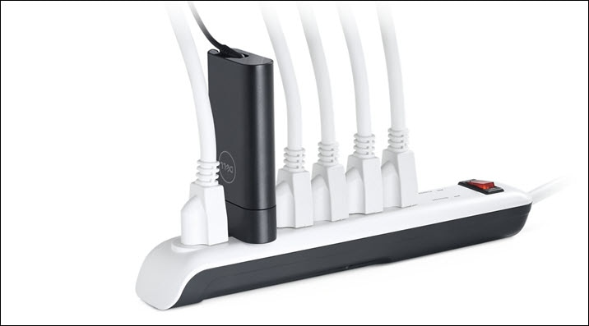
Step 2: Inspecting the AC Adapter and Cable
- Visual Inspection: Look for any physical damage or fraying on the power adapter, cable, or the power port on the laptop. If you notice any damage, stop using the device immediately and contact Dell Technical Support for repair options.
- Connection Check: Ensure the adapter or charger is securely connected to the laptop and the power source.
- Use a Different Adapter: Always use Dell provided or Dell-approved adapter or charger with your laptop. If available, test with a known working adapter to check if the adapter is faulty.
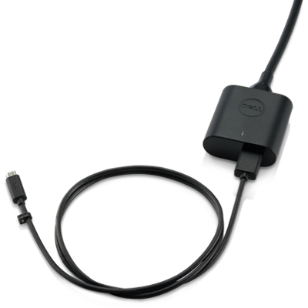
Step 3: Testing Without Battery
- Remove the Battery: If your laptop has a removable battery, remove it, and try to power on the laptop using only the AC adapter or charger. Refer to the laptop’s user guide or service manual. If the laptop turns on without the battery, contact Dell Technical Support to explore repair options available in your location based on your device’s warranty status.
Step 4: Resetting the Real-Time Clock (RTC)
Real-time clock (RTC) reset restores the BIOS to factory default settings and resets the date and time. The reset process may restart the laptop several times depending on how it is configured.
Note: Real-time clock (RTC) reset is only available on some Alienware, Inspiron, Latitude, Precision, Vostro, and XPS laptops.
- Unplug the Device: Disconnect all external devices.
- Connect AC Adapter: Plug in the ac adapter or charger to the laptop.
- Hold the Power Button: Press and hold the power button for 30-35 seconds, until the power LED blinks three times to discharge residual power.
- Release Power Button: Release the power button to complete the real-time clock reset.
Note: If the power is interrupted or the power button is held for less than 25 seconds or longer than 40 seconds, the reset process is aborted. Attempt to reset the RTC again.
- Reconnect and Test: Plug the adapter back in and try to power on the laptop.
If the above steps didn't resolve the power issue on your laptop or you suspect hardware failure or damage, contact Dell Technical Support to explore repair options available in your location based on your laptop’s warranty status.

Troubleshooting a Dell Desktop That Does Not Turn On
Follow this troubleshooting sequence outlined below to systematically address power issues with your desktop.
Step 1: Inspecting the Power Button and Cables
- Visual Inspection: Check the power button for any physical damage or sticking issues.
- Cable Connections: Ensure the power cable is securely connected to the power supply. Ensure that all the internal power cables are connected properly to the motherboard and components.
- Swap Power Cable: Attempt to swap the power cable with the monitor power cable. A faulty power cable may cause power issues.
Step 2: Testing with a Different Power Outlet
- Change Outlets: Plug the desktop into a different wall outlet to identify a faulty power outlet.
- Check the Power Strip: When using a power strip or surge protector, make sure it’s turned on and working properly. If possible, bypass the power strip to check if the power strip is faulty.
Step 3: Checking the Power Supply
- Unplug the Power Cable: Disconnect the power cable from the power supply unit (PSU).
- Hold the Power Button: Press and hold the power button for 15-20 seconds to discharge residual power.
- Test Power Supply Unit: On select Dell desktops, there is a Built-In Self-Test (BIST) button located on the power supply. Reconnect the power cable. Press this button to check if the LED turns on.
  - LED Response: If the LED turns on, the power supply is functioning properly. Go to the next step.
  - No LED Response: If the LED does not turn on, it indicates a faulty power supply. Contact Dell Technical Support to explore repair options available in your location based on your device’s warranty status.
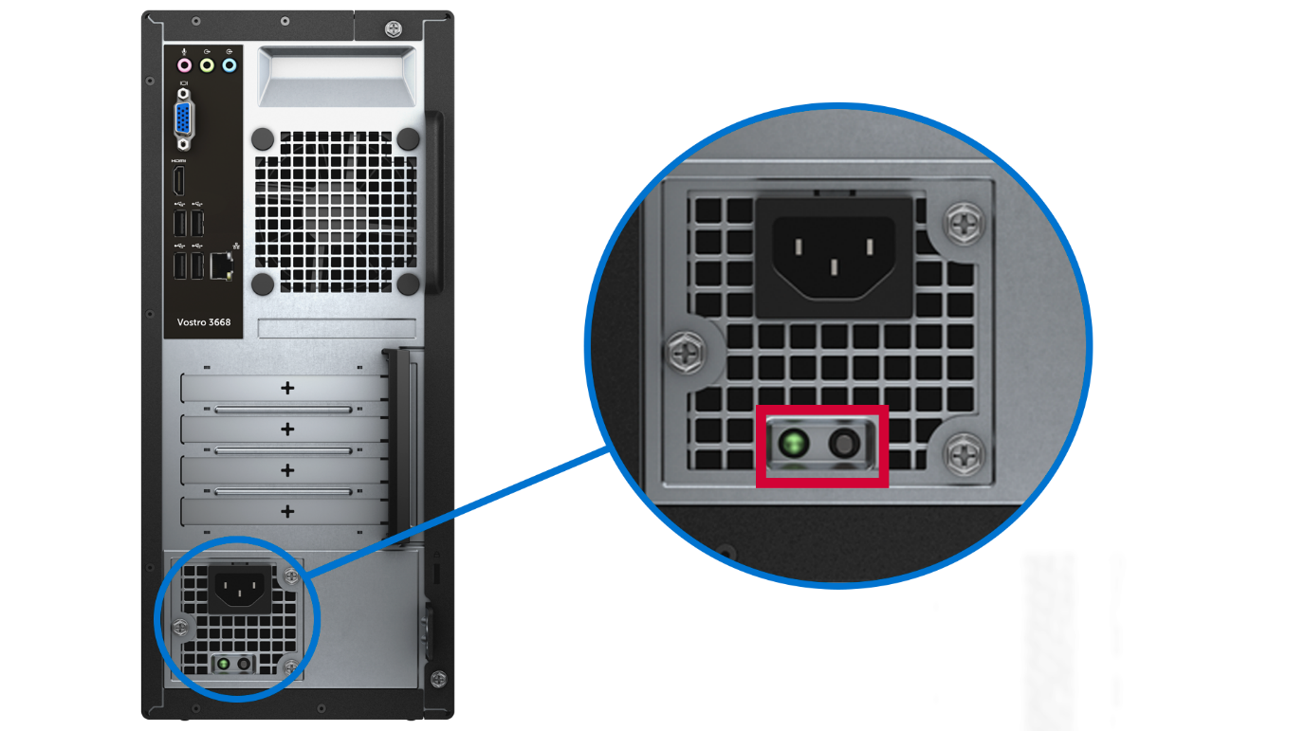
Step 4: Resetting the Real-Time Clock (RTC)
Real-time clock (RTC) reset restores the BIOS to factory default settings and resets the date and time. The reset process may restart the desktop multiple times depending on the configuration.
Note: Real-time clock (RTC) reset is only available on supported Inspiron, OptiPlex, Precision, Vostro, and XPS desktops.
- Unplug the Device: Disconnect all external devices and ensure the desktop is turned off.
- Hold the Power Button: Press and hold the power button for 30-35 seconds.
- Release Power Button: Release the power button to complete the real-time clock reset.
Note: If the power is interrupted or the power button is held for less than 25 seconds or longer than 40 seconds, the reset process is aborted. Attempt to reset the RTC again.
- Reconnect and Test: Plug the power cable back in and try to power on the desktop.
If the above steps didn't resolve the power issue on your Dell desktop, or you suspect hardware failure or damage, contact Dell Technical Support to explore repair options available in your location based on your desktop’s warranty status.

Frequently Asked Questions (FAQs)
Here are some frequently asked questions related to power issues on Dell laptops or desktops.
1. What should I do if the power button is stuck?
- If the power button is stuck, try these steps:
- Gently Press the Power Button: Try pressing the button gently to see if it can be dislodged.
- Check for Obstructions: Inspect around the power button for any dirt, dust, or debris that may be causing it to stick. Use a soft brush or compressed air to clean the area.
- Carefully Pry the Power Button: If the button remains stuck, you can try to use a thin, flat tool (like a plastic card or a plastic pry tool) to carefully try to pry the button free. Be cautious to avoid damaging the button or the surrounding area.
- Contact Dell Support: If the button remains stuck or appears damaged, contact Dell Technical Support for repair options available at your location based on the device’s warranty cover.
2. What should I do if my Dell laptop won’t turn on?
- Try another power outlet.
- Connect the AC adapter directly to a wall outlet, bypass surge protector or power strip.
- Inspect the AC adapter for damage. If the LED is off, reseat the power cable. If the LED remains off, replace the AC adapter.
- If the LED is on, reset the real-time clock (RTC) and attempt to power on with only the AC adapter.
3. What if my computer powers on but the screen stays black?
- Check for display issues by connecting an external monitor.
- If the external display works, the issue might be with the laptop screen.
- If not, it could be a graphics card or system board problem. Let us help you diagnose and fix common display issues with your computer.
4. Why does my computer power on but not boot up?
- This could be due to hardware issues or a corrupted operating system. Let us help you recover your computer from boot issues.
5. Why does my computer beep but not turn on?
- Beep codes indicate hardware issues.
- Refer to the user's manual of your computer to understand what the beep code means. Common issues include system memory (RAM) or system board problems.
- Let us help you recover your Dell computer from startup or no POST issue
6. How can I tell if my Dell desktop’s power supply is failing?
- Look for signs such as unusual noise, burning smell, or intermittent power issues. The LED on the power supply remains off if the power supply is faulty.
- Pressing the BIST button (test button) on the power supply unit (PSU) of the desktop does not turn on the PSU LED.
- These symptoms indicate a hardware failure. Contact Dell Technical Support for repair options available at your location based on the device’s warranty coverage.
7. Why does my Dell laptop battery drain quickly?
- Check for background applications. Close apps that you are not using.
- Download and install the latest drivers and operating system updates.
- Verify battery health through the BIOS, Dell Power Manager, Dell Optimizer, or SupportAssist battery diagnostics.
8. Can a faulty charger/adapter cause power issue with my Dell laptop?
- Yes, a faulty charger can lead to charging and power problems.
- Test with a different charger to confirm.
- Always use the Dell provided or Dell-approved adapters or chargers.
9. Why does my Dell desktop keep restarting?
- Check for overheating, faulty hardware, or software issues.
- Run a hardware diagnostic test to identify potential hardware issues.
- Download and install the latest drivers and operating system updates.
10. How can I prevent power issues in the future?
- Always use Dell provided or Dell-approved adapters or chargers and power cables. Use a surge protector.
- Ensure proper ventilation.
- Keep the device clean.
- Regularly update software and drivers.

11. What should I do if I hear beep codes or see LEDs blinking in a pattern?
Beep codes and LED blink patterns indicate specific hardware issues. Here’s how to address them:
- Identify the Pattern: Count the number of beeps or blinks to determine the error code.
- Consult the Manual: Refer to the user's manual of your device to understand the meaning of the specific code.
- Troubleshoot the Issue: Based on the code, check related components. For example, if the code indicates RAM or system memory issues, try to reseat, or replace the system memory modules.
- Check the Hardware: Access Dell Diagnostics (pre-boot system assessment) by pressing F12 during startup and selecting “Diagnostics”. If the diagnostic test fails, make a note of the error code, validation code, Service Tag, and then look up the error code.
- Contact Dell Support: If the diagnostic test fails or if the issue persists, contact Dell Technical Support to explore repair options available in your location based on your device’s warranty status.
12. When should I contact Dell Support for power issues?
- If the troubleshooting steps provided in this article do not fix the power issue or you suspect hardware failure, contact Dell Technical Support. We will help you explore repair options available in your location based on your device’s warranty status.
13. What should I do if my computer randomly shuts down?
- Random shutdowns may be caused by overheating, power supply issues, or hardware failures.
- Ensure proper ventilation.
- Check the power supply unit (PSU) or charger.
- Access Dell Diagnostics (pre-boot system assessment) by pressing F12 during startup and selecting “Diagnostics”.
- If the diagnostic test fails, make a note of the error code, validation code, Service Tag, and then look up the error code
14. Why does my computer restart instead of shutting down?
- This might be due to software issues, incorrect power settings, or hardware problems.
- Download and install the latest drivers and operating system updates.
- Check the power settings.
- Access Dell Diagnostics (pre-boot system assessment) by pressing F12 during startup and selecting “Diagnostics”.
- If the diagnostic test fails, make a note of the error code, validation code, Service Tag, and then look up the error code.
15. How can I fix a laptop that won’t wake up from sleep mode?
- Try pressing the power button briefly, move the mouse, connect the charger. Update the BIOS or UEFI firmware, and install the latest drivers if the issue persists.

16. Why won’t my laptop turn on when connected to a docking station?
- Power Supply: Ensure the docking station is connected to a working power outlet. Try using a different power outlet.
- Connection Issues: Check that the docking station is securely connected to your laptop.
- Docking Station Compatibility: Ensure that the docking station is compatible with your laptop model. Some docking stations may not support certain laptop models.
- Power Requirements: Ensure the docking station meets the power requirements of your laptop. Some docking stations may not provide sufficient power to charge and run the laptop simultaneously. Check the specifications of both the docking station and your laptop to ensure compatibility.
- Laptop Battery: Sometimes, if the laptop’s battery is completely drained, it might not turn on when connected to a docking station. Try charging the laptop directly with it’s AC adapter first.
- Need more help with your Dell docking station? Check out our docking station support page for self-help resources and troubleshooting tips.
Additional Resources
Explore these recommended resources related to this topic.
- Recover Your Dell PC from Startup or POST Issue
- Fix Common Display Issues with Monitors or Laptop Screens
- Fix Boot Issues: System Does Not Boot into Windows
- Troubleshoot and Fix Laptop Battery Not Charging
- Resolve Laptop AC Adapter or Charger Issues
- Check, Maintain, and Optimize Laptop Battery Health

